*IoT-based Smart Classroom Environment*

Dr. Annapurna D   
*Computer Science and Engineering*  
*PES University*Bengaluru, India  
annapurnad@pes.edu

Akshaya Visvanathan   
*Computer Science and Engineering*  
*PES University*Bengaluru, India  
akshayavisu@gmail.com

Akhil Kumar  
*Computer Science and Engineering*  
*PES University*Bengaluru, India  
akhilskumar1999@gmail.com

Bhavan Naik  
*Computer Science and Engineering*   
*PES University*Bengaluru, India  
bhavannaik@gmail.com

Atharva Moghe  
*Computer Science and Engineering*  
*PES University*Bengaluru, India  
atm171199@gmail.com

***Abstract*— For years, universities have been using traditional methods as they bring about a sense of familiarity and comfort. However, the key to increase productivity and enhance the learning experience lies in the modernization of our college campuses. Our work focuses on two of the most pressing issues - attendance and unsolicited energy consumption. Our goal was to overhaul the manual system, without compromising its integrity. A portable RFID fingerprint scanner that must be activated by the professor, thereby making our system failproof.**

**The data generated is stored in a cloud server and is used to draw behavioural patterns. We are accustomed to leaving our fans and lights unattended, which poses a serious environmental threat. Our solution is to build a smart eco-system to detect the presence of a person, and automatically switch on the necessary appliances. Further, this in combination with various algorithms can be used to adjust the speed of fans and brightness of lights based on external factors.**

***Keywords—Internet of Things, Smart Classroom Systems, Smart University, Automatic Attendance, Energy Optimization, Fingerprint scanner, Windows Application.***

# Introduction

This is a proposal for an IoT-based intelligent environment, with the primary objective of energy optimization and an intelligent, yet reliable attendance system that focuses on reducing latency to give an enhanced learning experience.

Any educational organization (it maybe small or large) requires a students or employees attendance tracking system for the effective maintenance of different projects and tasks assigned to them. The management finds it absolutely necessary to collect and maintain up to date attendance data, sometimes even over a span of several months. This not only shows professionalism but also is crucial in case of any discrepancies in the future. We have seen that manual attendance tracking is a very tedious and inefficient process for even a fairly large group of students. Hence, an automated system of attendance takes a huge leap in this scenario.

A smart attendance system is very essential in present days. An effective and adequate system of attendance helps in monitoring the punctuality and progress of students and also, managing the absence of people. There are a few steps to enabling a smart attendance system. It consists of setting up the workflows for attendance and also maintaining a proper validation of student’s effective class time. However, this should be implemented by keeping the sensitive nature of data in mind. The chances of bypassing such a system must be minimized.

Another major issue observed in a university campus is the unrestrained use of electricity. This puts a direct strain on our country’s energy resources and in turn causes irreparable damage to the environment. As a responsible human, it is our duty to conserve the earth and leave behind a better world for our future generations. Unattended fans, lights and other electrical appliances account for a large portion of our country’s economy.

# Literature Survey

## [Marian Caţă](https://ieeexplore.ieee.org/author/37085701764) in her paper, Smart University, A New Concept in IoT, states that “The concept of a smart environment in this given paper is defined like a small world where devices enabled by sensors and networking work together continuously to make the lives of those in the environment more comfortable.” The varied number of smart devices on a university campus helps generate and analyze a large volume of data and make informed decisions.

In conclusion, she has enumerated the advantages of making the switch from traditional systems into IoT based smart systems part or as a whole in other domains, both in the educational field (universities, colleges, schools, kindergartens) and in other areas, including private business environments.

## The students of Nanjing University of Posts and Telecommunications, Nanjing, CN, reiterate in their paper that the manual method is not only time-consuming but also riddled with high chances of errors. It also entails a constant risk of physical by-passing by some notorious staff members or students.

“In this paper, we proposed a device-free office attendance system and presented our key motivation, design methodologies, implementation, and evaluation of this system, which can distinguish various targets according to the unique phase signals of individuals in the LOS link, as collected from an RFID reader. To improve system identification accuracy, we used a frequency distribution histogram and a K-means algorithm to extract phase fingerprints.”

## In their paper, Automatic lighting and Control System for Classroom, the authors have discussed a system in which “the area of the classroom is divided into a number of equal grids by motion sensors placed at various vantage points. They detect the presence of a person in a particular grid, and send a signal to the relay to automatically switch on the corresponding fans and lights. In future, research can be carried out towards not only switching the appliances on or off but also altering the intensity of lights and speed of fans on the basis of environmental factors such as temperature and humidity.”

## 

## In ,Smart Attendance Monitoring System (SAMS), [Shubhobrata Bhattacharya](https://ieeexplore.ieee.org/author/37085994705) and her colleagues observed rightly that “In any institution, attendance records hold a lot of prominence in understanding the effectiveness of classes and helps in the management’s constant lookout to improve and enhance the experience of education for both students as well as faculty. Convenience and fault-tolerance are the most important aspects for any smart attendance system. For this they employed a Face detection system that used the Viola-James algorithm for effective detection..”

“The primary goal of an automated attendance system is to overhaul the traditional and time-consuming system prevalent even today. The implemented system keeps track of attendance by detecting some facial features and then recognizing them. These systems perform convincingly with different facial expressions, poses of the person and lighting in the background.[5] However, one of the major drawbacks of this system is its inability to recognize valid faces from time to time.”

# Proposed Methodology

* Attendance:

1. Attendance can be taken electronically by means of a biometric optical fingerprint scanner.
2. Security and integrity can be ensured by making the biometric module portable and modular - a small phone sized module carried by the teachers.
3. The teacher can pass around/have each of the students scan their prints and register their attendance with no manual intervention.

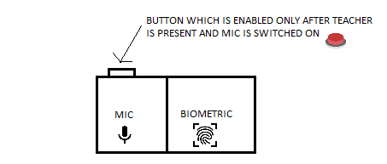

Figure 1: Attendance Module Diagram

The above figure shows our biometric attendance module fixed along with the mic system which the teachers carry around for their classes.

* Electricity Optimization Module:

1. Spatial sensors placed at the edges of classrooms will notify the system of movement and activity in the room.
2. Edge computed algorithms ensure that the lights and fans are turned on only at specific portions of the room incase of a large classroom/hallway.
3. In case of manual fans, temperature monitors are used to add a level of cost-effective automation.

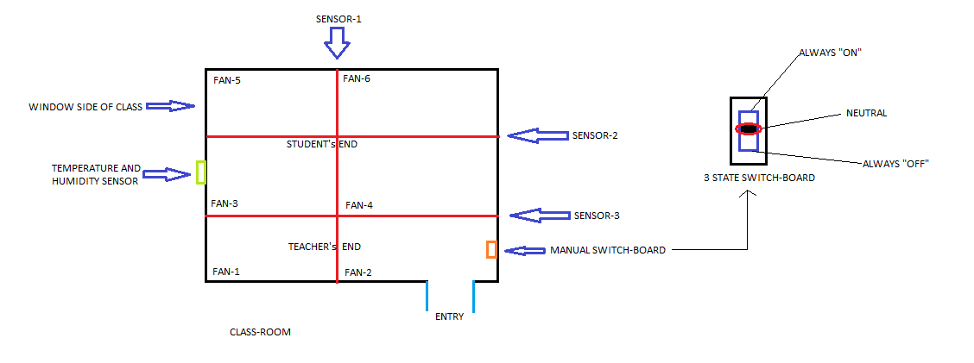

Figure 2: Electricity Optimization Module Diagram

The above figure shows a diagrammatic representation of a class after we install all the components in it.

* Windows Application:

1. The administrators need a central server to work on all the different data that is sent by the sensors to them.
2. This Windows Application acts as an information hub and one that can also assist the teachers with various other options like swapping classes, viewing time-tables, booking an extra class, etc.
3. The application has separate logins for the students and the professors. It shows graphs that help understand the students the areas that they need to pay attention to.
4. The application also helps the admin to generate detailed reports on attendance for a particular subject and every individual student’s attendance.

* Database Module:

1. A lot of data goes into the project considering the fact that we have many different sensors.
2. To store them, we build different schemas for the purpose of efficiently storing and retrieving data.
3. Data stored here is then retrieved and various analysis is performed on that data.

Schema:

The data from the FPS scanner is transferred to the microprocessor (in this case, the ESP-32) handling it which in-turn sends the data to the database. This data is stored in the input table. The data stored in the input table contains Date-Time of marking attendance and SRN. Using this data, we map to the particular period number using the period number table. When we get the period number, we use the timetable to find exactly which class this attendance was marked for. Note that this subject can be changed using our Windows application as well.

And then, the final data along with the subject name, date and period number is stored in the output table, which then can be used for visualization and analysis. We also have the student data table that stores all the details about a student and a marks table to store the grades of the particular student. All the tables which are related to the student are mapped using SRN as their primary/foreign key.

* Data Visualization and Analysis:

1. We generate a lot of data and hence visualize these with the help of different graphs.
2. From this various kinds of data, we can analyse the data and even come upto some important conclusions from our project.
3. Building a model to find relationships between various variables present in our database.

* And finally, we integrate all these different modules into a single unit.
* We are trying to build a fool-proof system in this project considering the ways students can bypass these systems.
* This is a real-time implementation of the project that is independent of the wiring system of the institutions.

# Result Analysis

## Tests:

These are the set of tests we carried for each module:

1. Attendance Module:

* Checking if the fingerprint scanner is working or not.
* Checking if the fingerprint scanner is able to map the fingerprint to the ID of the student.
* Checking if the data sent to the database is correct or not.

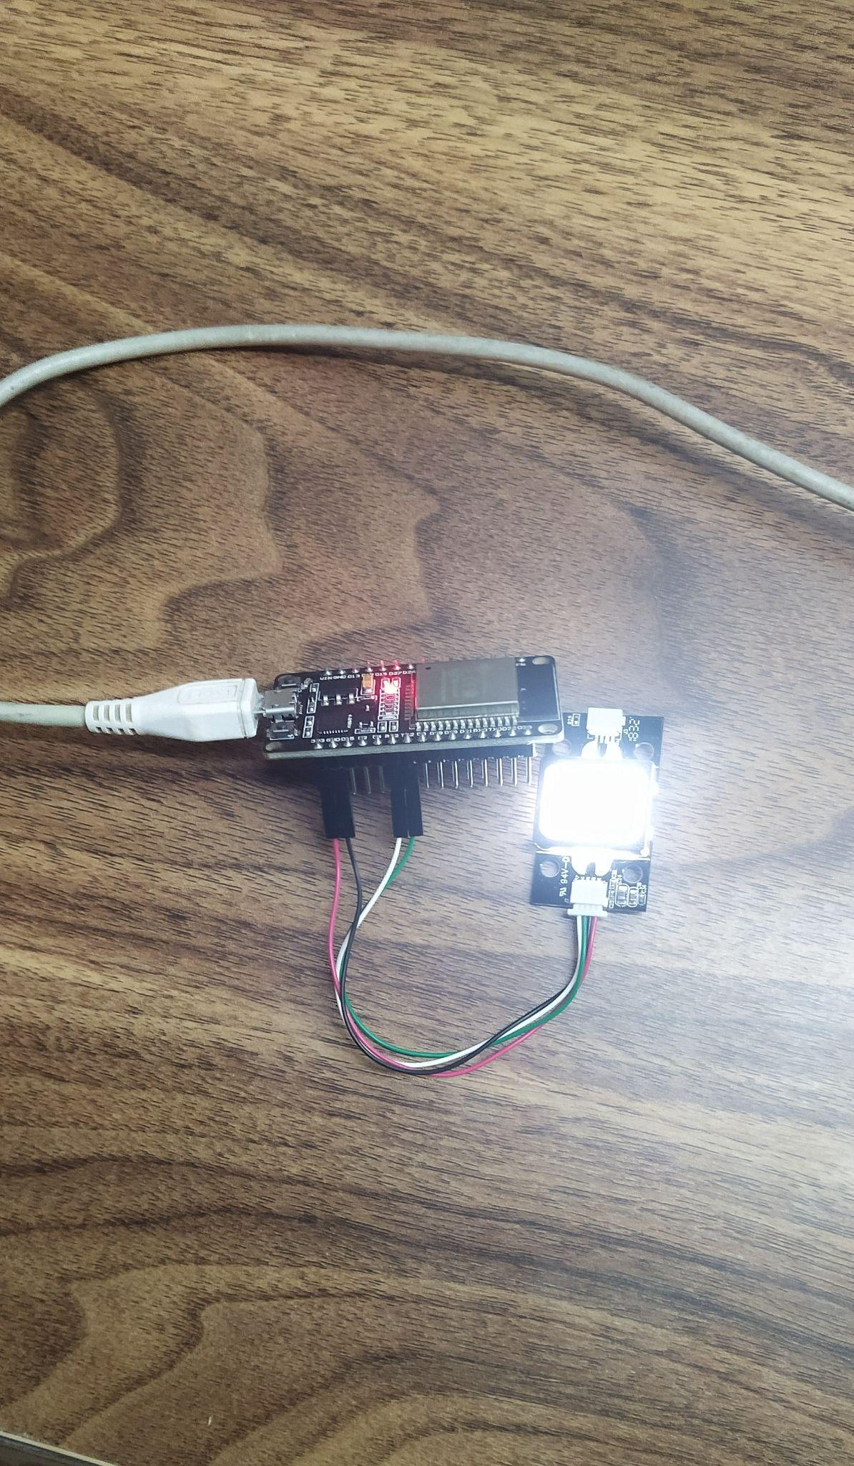

Figure 3: Image of Attendance Module

1. Electricity Optimization Module:

* Checking if the module senses motion.
* Checking if the module sends correct data to the database.

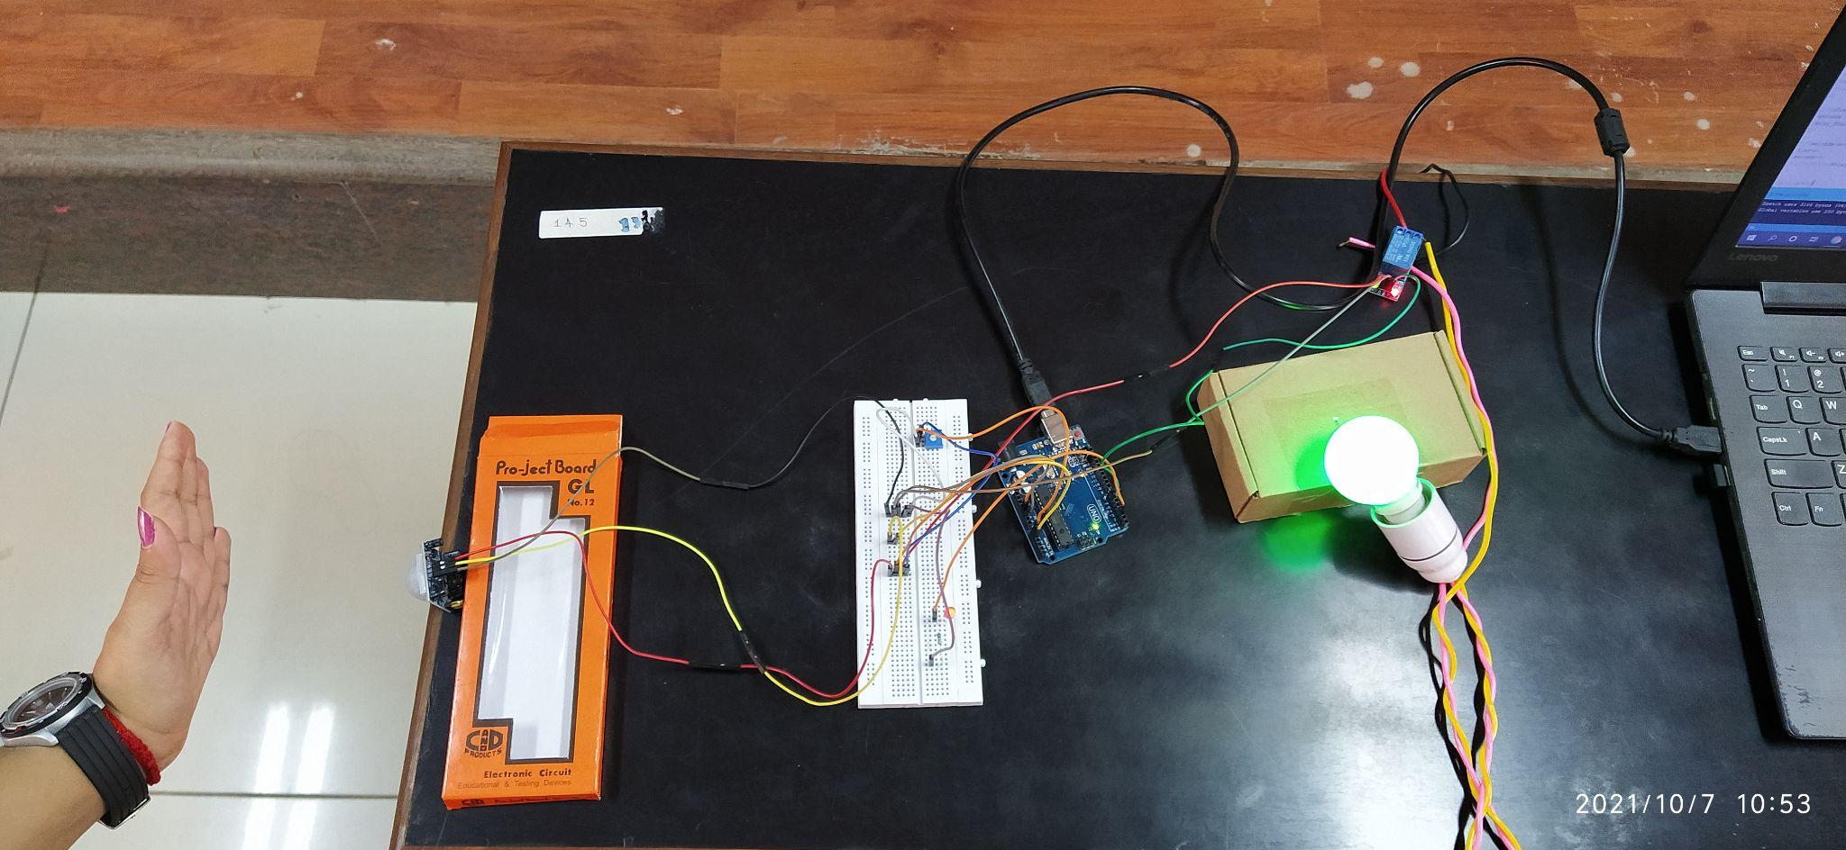

Figure 4: Image of the Electricity Optimization Module

1. Windows Application:

* Checking if the app is able to change/update the database.
* Checking if the app is able to handle multiple logins at the same time.
* Checking if the app gives the right data back to the admin.

1. Database System:

* Checking the data sent by fingerprint scanner and map it to the correct class and marking the status.
* Checking the data sent by the electricity optimization module and adding correct values to the database.
* Checking the data given by the system to the admin is correct or not.

## Results:

* Results are the same as expected from the system.
* All the modules are working as they are supposed to be running.
* The only deviation from the original plan is that we were not able to collect data from all students of a particular class due to the pandemic and only data belonging to the group members is used in this project.
  1. *Comparisons:*
* The existing systems either have face recognition technology or take a longer duration for fingerprint scanner for marking the attendance.
* The system which we built is quick and fool-proof. Even if attendance isn’t marked for some server error, the student can approach the teacher and can manually be marked present right after the class.
* The model which we built for analysis gives an accuracy around 85%. (Note that it contains data belonging to the project members only and not the entire class)
* All-in-all, our project reacts quicker than the existing systems, thereby making it a better-suited model for institutions.

##### Acknowledgment

We would like to express our gratitude to Dr. Annapurna D., Department of Computer Science and Engineering, PES University, for her continuous guidance, assistance, and encouragement throughout the development of this project.

We are grateful to the project Coordinator,Dr. Sarasvathi V, Associate Professor, for organizing, managing, and helping with the entire process.

We take this opportunity to thank Dr. Sandesh B J, Chairperson, Professor, Department of Computer Science and Engineering, PES University, for all the knowledge and support we have received from the department. We would like to thank Dr. B.K. Keshavan, Dean of Faculty, PES University for his help.

We are deeply grateful to Dr. M. R. Doreswamy, Chancellor, PES University, Prof. Jawahar Doreswamy, Pro Chancellor – PES University, Dr. Suryaprasad J, Vice-Chancellor, PES University for providing to us various opportunities and enlightenment every step of the way. Finally, this project could not have been completed without the continual support and encouragement we have received from our family and friends.

##### Conclusions

In this paper, we have proposed an IoT-based smart classroom environment. Our automatic fingerprint-based attendance system aims at solving the issues of the existing attendance methods and systems. It uses a fingerprint scanner to mark the student’s attendance and works impressively across all different conditions. Interestingly, this module is attached to the regular mic systems the teachers carry during class hours.

The other important component was the electricity optimization module. That component uses PIR sensors and automatically switches on the electricity components in the classroom. This module also works brilliantly during trials.

Finally, we combined all of these using a Windows application and stored data into our database. We also did some analysis on this data that we obtained from the attendance and classroom system.

Our IoT-based Smart Classroom Environment can be reused in part or also as a whole, across various other domains like private business/ company environments.

##### Future Work

* Due to the restrictions posed by the pandemic, our project is a model and not a product.
* Install the complete module in our campus and get a steady flow of real time data to a centralized server, ThingSpeak and perform analysis.
* To extend the project from one institution to multiple institution level.
* Add a couple of other modules to get an all-in-one feature system.

##### References

1. Y. Mehmood, F. Ahmad, I. Yaqoob, A. Adnane, M. Imran and S. Guizani, "Internet-of-Things-Based Smart Cities: Recent Advances and Challenges," in IEEE Communications Magazine, vol. 55, no. 9, pp. 16-24, Sept. 2017, doi: 10.1109/MCOM.2017.1600514.
2. https://www.vxchnge.com/blog/iot-statistics
3. AItalk: a tutorial to implement AI as IoT devices
4. M. Caţă, "Smart university, a new concept in the Internet of Things," 2015 14th RoEduNet International Conference - Networking in Education and Research (RoEduNet NER), 2015, pp. 195-197, doi: 10.1109/RoEduNet.2015.7311993.
5. Q. Miao, F. Xiao, H. Huang, L. Sun and R. Wang, "Smart attendance system based on frequency distribution algorithm with passive RFID tags," in Tsinghua Science and Technology, vol. 25, no. 2, pp. 217-226, April 2020, doi: 10.26599/TST.2018.9010141.
6. J. Yu, W. Gong, J. Liu, L. Chen, K. Wang and R. Zhang, "Missing Tag Identification in COTS RFID Systems: Bridging the Gap between Theory and Practice," in IEEE Transactions on Mobile Computing, vol. 19, no. 1, pp. 130-141, 1 Jan. 2020, doi: 10.1109/TMC.2018.2889068.
7. Suresh S., H. N. S. Anusha, T. Rajath, P. Soundarya and S. V. P. Vudatha, "Automatic lighting and Control System For Classroom," 2016 International Conference on ICT in Business Industry & Government (ICTBIG), 2016, pp. 1-6, doi:10.1109/ICTBIG.2016.7892666.
8. S. Bhattacharya, G. S. Nainala, P. Das and A. Routray, "Smart Attendance Monitoring System (SAMS): A Face Recognition Based Attendance System for Classroom Environment," 2018 IEEE 18th International Conference on Advanced Learning Technologies (ICALT), 2018, pp. 358-360, doi: 10.1109/ICALT.2018.00090.
9. IOT AND AI IN HEALTHCARE: A SYSTEMATIC LITERATURE REVIEW
10. S. M. Felix, S. Kumar and A. Veeramuthu, "A Smart Personal AI Assistant for Visually Impaired People," 2018 2nd International Conference on Trends in Electronics and Informatics (ICOEI), 2018, pp. 1245-1250, doi: 10.1109/ICOEI.2018.8553750.
11. V. Chamola, V. Hassija, V. Gupta and M. Guizani, "A Comprehensive Review of the COVID-19 Pandemic and the Role of IoT, Drones, AI, Blockchain, and 5G in Managing its Impact," in IEEE Access, vol. 8, pp. 90225-90265, 2020, doi: 10.1109/ACCESS.2020.2992341.
12. A review on intelligent process for smart home applications based on IoT: coherent taxonomy, motivation, open challenges, and recommendations.
13. W. Chen, Y. Lin, F. Ng, C. Liu and Y. Lin, "RiceTalk: Rice Blast Detection Using Internet of Things and Artificial Intelligence Technologies," in IEEE Internet of Things Journal, vol. 7, no. 2, pp. 1001-1010, Feb. 2020, doi: 10.1109/JIOT.2019.2947624.
14. D. He and S. Zeadally, "An Analysis of RFID Authentication Schemes for Internet of Things in Healthcare Environment Using Elliptic Curve Cryptography," in IEEE Internet of Things Journal, vol. 2, no. 1, pp. 72-83, Feb. 2015, doi: 10.1109/JIOT.2014.2360121.
15. R. Sarmah, M. Bhuyan and M. H. Bhuyan, "SURE-H: A Secure IoT Enabled Smart Home System," 2019 IEEE 5th World Forum on Internet of Things (WF-IoT), 2019, pp. 59-63, doi: 10.1109/WF-IoT.2019.8767229.

##### Appendix: Definitions, Acronyms and Abbreviations

* ThingSpeak: Open-source IoT application and API to store and retrieve data from things using the HTTP and MQTT protocol over the Internet or via LAN.
* Capacitive Fingerprint Scanner: uses capacitance to gauge the depth of the finder and collect the fingerprint.
* Relay: A relay is an electrically operated switch. It consists of a set of input terminals for a single or multiple control signals, and a set of operating contact terminals.
* Thermostat: A thermostat is a regulating device component which senses the temperature of a physical system and performs actions so that the system's temperature is maintained near a desired setpoint.
* Microcontroller: A microcontroller is a small computer on a single metal-oxide-semiconductor integrated circuit chip.